DAY 7 REPORT – MODEL IMPROVEMENT & FINAL MODEL

Title: Brain Tumor Detection using Deep Learning

1. Objective
The objective of Day 7 is to improve model performance using hyperparameter tuning, regularization techniques such as Dropout and Batch Normalization, and learning rate tuning, and to finalize and save the best-performing model.

2. Improvement Overview
In this stage, the best-performing model from previous days is further optimized to improve accuracy, reduce overfitting, and enhance generalization on unseen data.

3. Hyperparameter Tuning
The following hyperparameters were tuned:
- Learning rate
- Number of epochs
- Number of trainable layers (fine-tuning depth)
- Batch size
These adjustments helped improve model convergence and performance.

4. Regularization Techniques

🔹 Dropout
- Randomly disables neurons during training
- Helps prevent overfitting

🔹 Batch Normalization
- Normalizes activations
- Stabilizes and speeds up training

5. Learning Rate Optimization
Two learning rates were used:
- Higher learning rate → Initial training
- Lower learning rate → Fine-tuning
This ensures stable and efficient learning.

6. Early Stopping
Early stopping was applied to avoid overfitting:
from tensorflow.keras.callbacks import EarlyStopping

early_stop = EarlyStopping(patience=3, restore_best_weights=True)
Stops training when validation performance stops improving.

7. Improved Model Architecture
The model was enhanced by adding:
- Batch Normalization
- Dropout layers
- Optimized dense layers
- Model: "functional_3"
- ┏━━━━━━━━━━━━━━━━━━━━━━━━━━━━━━━━━━━━━━━━━━━━━━━━━━━━━┳━━━━━━━━━━━━━━━━━━━━━━━━━━━━━━━━━━━━━━━━┳━━━━━━━━━━━━━━━━━━━
- ┃ Layer (type) ┃ Output Shape ┃ Para
- ┡━━━━━━━━━━━━━━━━━━━━━━━━━━━━━━━━━━━━━━━━━━━━━━━━━━━━━╇━━━━━━━━━━━━━━━━━━━━━━━━━━━━━━━━━━━━━━━━╇━━━━━━━━━━━━━━━━━━━
- │ input_layer_3 (InputLayer) │ (None, 224, 224, 3) │
- ├─────────────────────────────────────────────────────┼────────────────────────────────────────┼───────────────────
- │ block1_conv1 (Conv2D) │ (None, 224, 224, 64) │ 1,
- ├─────────────────────────────────────────────────────┼────────────────────────────────────────┼───────────────────
- │ block1_conv2 (Conv2D) │ (None, 224, 224, 64) │ 36,
- ├─────────────────────────────────────────────────────┼────────────────────────────────────────┼───────────────────
- │ block1_pool (MaxPooling2D) │ (None, 112, 112, 64) │
- ├─────────────────────────────────────────────────────┼────────────────────────────────────────┼───────────────────
- │ block2_conv1 (Conv2D) │ (None, 112, 112, 128) │ 73,
- ├─────────────────────────────────────────────────────┼────────────────────────────────────────┼───────────────────
- │ block2_conv2 (Conv2D) │ (None, 112, 112, 128) │ 147,
- ├─────────────────────────────────────────────────────┼────────────────────────────────────────┼───────────────────
- │ block2_pool (MaxPooling2D) │ (None, 56, 56, 128) │
- ├─────────────────────────────────────────────────────┼────────────────────────────────────────┼───────────────────
- │ block3_conv1 (Conv2D) │ (None, 56, 56, 256) │ 295,
- ├─────────────────────────────────────────────────────┼────────────────────────────────────────┼───────────────────
- │ block3_conv2 (Conv2D) │ (None, 56, 56, 256) │ 590,
- ├─────────────────────────────────────────────────────┼────────────────────────────────────────┼───────────────────
- │ block3_conv3 (Conv2D) │ (None, 56, 56, 256) │ 590,
- ├─────────────────────────────────────────────────────┼────────────────────────────────────────┼───────────────────
- │ block3_pool (MaxPooling2D) │ (None, 28, 28, 256) │
- ├─────────────────────────────────────────────────────┼────────────────────────────────────────┼───────────────────
- │ block4_conv1 (Conv2D) │ (None, 28, 28, 512) │ 1,180,
- ├─────────────────────────────────────────────────────┼────────────────────────────────────────┼───────────────────
- │ block4_conv2 (Conv2D) │ (None, 28, 28, 512) │ 2,359,
- ├─────────────────────────────────────────────────────┼────────────────────────────────────────┼───────────────────
- │ block4_conv3 (Conv2D) │ (None, 28, 28, 512) │ 2,359,
- ├─────────────────────────────────────────────────────┼────────────────────────────────────────┼───────────────────
- │ block4_pool (MaxPooling2D) │ (None, 14, 14, 512) │
- ├─────────────────────────────────────────────────────┼────────────────────────────────────────┼───────────────────
- │ block5_conv1 (Conv2D) │ (None, 14, 14, 512) │ 2,359,
- ├─────────────────────────────────────────────────────┼────────────────────────────────────────┼───────────────────
- │ block5_conv2 (Conv2D) │ (None, 14, 14, 512) │ 2,359,
- ├─────────────────────────────────────────────────────┼────────────────────────────────────────┼───────────────────
- │ block5_conv3 (Conv2D) │ (None, 14, 14, 512) │ 2,359,
- ├─────────────────────────────────────────────────────┼────────────────────────────────────────┼───────────────────
- │ block5_pool (MaxPooling2D) │ (None, 7, 7, 512) │
- ├─────────────────────────────────────────────────────┼────────────────────────────────────────┼───────────────────
- │ flatten_1 (Flatten) │ (None, 25088) │
- ├─────────────────────────────────────────────────────┼────────────────────────────────────────┼───────────────────
- │ batch_normalization_5 (BatchNormalization) │ (None, 25088) │ 100,
- ├─────────────────────────────────────────────────────┼────────────────────────────────────────┼───────────────────
- │ dense_6 (Dense) │ (None, 256) │ 6,422,
- ├─────────────────────────────────────────────────────┼────────────────────────────────────────┼───────────────────
- │ dropout_3 (Dropout) │ (None, 256) │
- ├─────────────────────────────────────────────────────┼────────────────────────────────────────┼───────────────────
- │ dense_7 (Dense) │ (None, 1) │
- └─────────────────────────────────────────────────────┴────────────────────────────────────────┴───────────────────
- Total params: 63,613,893 (242.67 MB)
- Trainable params: 21,187,905 (80.83 MB)
- Non-trainable params: 50,176 (196.00 KB)
- Optimizer params: 42,375,812 (161.65 MB)
Figure: Improved Model Architecture with Regularization

8. Performance Visualization
Training performance after improvements:
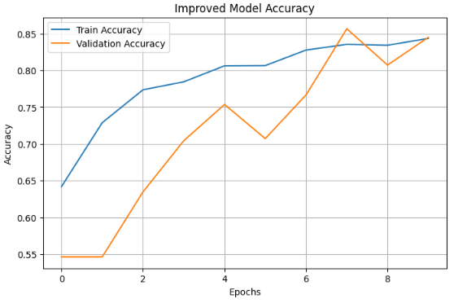
Figure: Improved Training vs Validation Accuracy

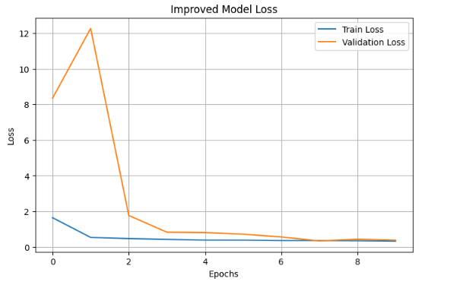
Figure: Improved Training vs Validation Loss

9. Final Model Evaluation
The optimized model was evaluated on test data.
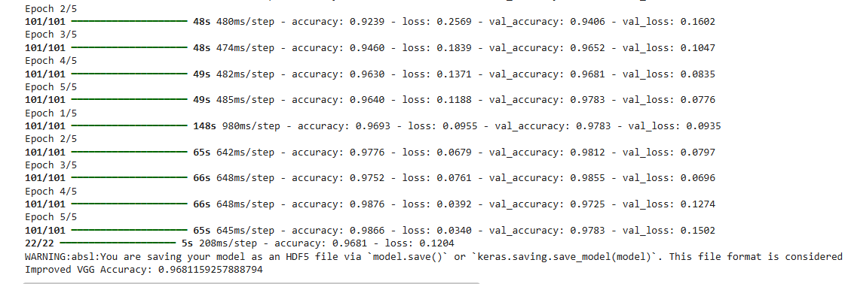
Figure: Final Model Accuracy After Optimization

10. Result Summary
- Final Accuracy: 96%
- Best Model: VGG

11. Key Improvements
- Reduced overfitting using dropout
- Improved training stability with batch normalization
- Better convergence using learning rate tuning
- Early stopping improved generalization

12. Challenges Identified
- Hyperparameter tuning required multiple experiments
- Increased training time
- Balancing underfitting and overfitting

13. Conclusion
Model performance was successfully improved using optimization techniques. The final model demonstrates better generalization and higher accuracy, making it suitable for brain tumor detection tasks.

14. Final Deliverable
The best-performing model was saved:
best_model.save("best_model.keras")
This model can be used for deployment or further testing.

15. Project Completion Summary
- Day 4 → Baseline CNN
- Day 5 → Transfer Learning
- Day 6 → Evaluation
- Day 7 → Optimization & Final Model

STORYBOARD
- Input: MRI Images
- Model: Transfer Learning
- Improvement: Dropout + BatchNorm
- Tuning: Learning Rate
- Training: Optimized model
- Output: Final best model

DAILY TASK REPORT

What I did today:
- Applied hyperparameter tuning
- Added dropout and batch normalization
- Tuned learning rate
- Used early stopping
- Improved model performance
- Saved best model

What I will do next:
- Prepare final project documentation
- Upload project to GitHub
- Add project to resume

Issues:
- Required multiple tuning trials
- Increased computational cost

